**Unearthing The Environmental Impact Of Human Activity: A Global CO2 Emission Analysis**

Submitted by

**A.HARI PRIYA**

(Reg.No.12020U25007)

**U.HEMAMALINI**

(Reg.No.12020U25008)

**P.DHIVYA**

(Reg.No.12020U25006)

**G.INDHUMATHI**

(Reg.No.12020U25009)

**DEPARTMENT OF**

**BACHELOR OF SCIENCE IN MATHEMATICS**



**KRISHNASAMY COLLEGE OF SCIENCE,ARTS &MANAGEMENT FOR WOMEN-CUDDALORE**

**PROJECT CONTENT**

1. **INTRODUCTION**
   1. **Overview**
   2. **Purpose**
2. **PROBLEM DEFINITION &DESIGN THINKING**
   1. **Empathy Map**
   2. **Ideation &Brainstorming Map**
3. **RESULT**
4. **ADVANTAGES & DISADVANTAGES**
5. **APPLICATIONS**
6. **CONCLUSION**
7. **FUTURE SCOPE**
8. **APPENDIX**

**A.SQL Source Code**

**B. HTML Source Code**

**1.INTRODUCTION**

**1.1 Overview**

Global warming is one of the biggest challenges currently being faced

by the human race, although correlation is not causation, a likely cause of global warming is due to increased atmospheric carbon dioxide from human activities. CO2 Emission refers to the Carbon Dioxide emitted throughout the world. For this analysis we will be focusing on CO2 Emissions and its effect on the world we live in as well as some key factors and stats that may play a role in the emission of CO2 globally. Fossil fuel use is the primary source of CO2. The data throws light onto how much fossil fuels are burnt, per year per nation, which amounts to an increase in CO2 every year. This will help researchers and environment experts to predict global warming. So countries should set a goal to decrease this amount yearly. Analysing Global Co2 Emission across countries from 1975 to 2020. This dataset contains a record of Co2 Emission by each Country and Region of Earth, here we are going to analyse and visualise Country wise, Region wise and Overall Co2 Emission on Earth.

**1.2 Purpose**

The business requirements for analysing the Co2 Emission Globally over time, identifying affecting factors, creating interactive dashboards and reports, identifying areas for improvement, making data-driven decisions, comparing to countries average and creating forecasting models for future performance. The ultimate goal is to gain insights and reduce the emission through data visualization techniques.

**Literature Survey**

A literature survey is a method of researching existing literature and studies related to a specific topic. In the context of analyzing the Global Co2 Emission, a literature survey would involve reviewing studies and articles that have been published on the topic of Emission, as well as studies specific to Co2.The literature survey would include sources such as academic journals, industry reports, and online articles. It would aim to identify different internal and external factors that are responsible and commonly used to determine Co2 Emission, as well as any best practices or strategies that have been identified for reducing emission.The literature survey would also explore any existing research on Co2 Emission specifically, and would aim to identify any challenges or opportunities that the Countries can opt to reduce emission.

**Social Or Business Impact**

Social Impact: Carbon dioxide emissions are the primary driver of global climate change. It’s widely recognised that to avoid the worst impacts of climate change, the world needs to urgently reduce emissions.

Business Model/Impact: By conducting an analysis the countries can identify areas for improvement and take steps to reduce factors that are responsible for Co2 Emission for environmental sustainability by improving the efficiency and transitioning to low carbon alternatives.

**2. PROBLEM DEFINITION & DESIGN THINKING**

**2.1 Empathy Map**

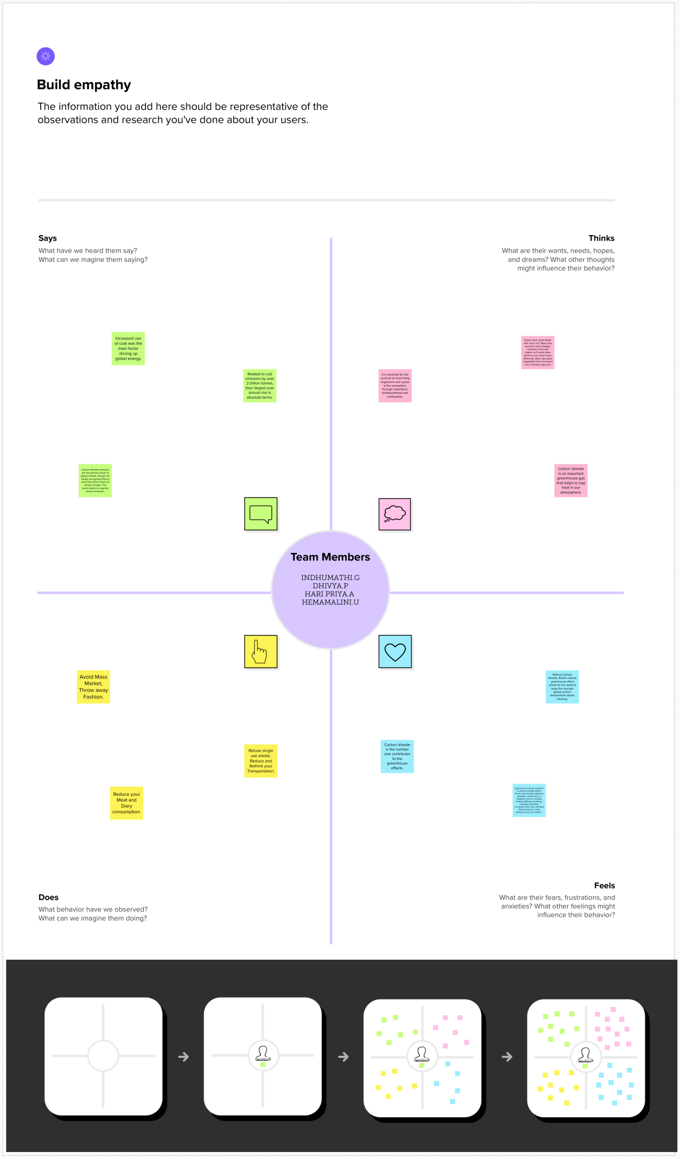

**2.2 Ideation & Brainstroming Map**

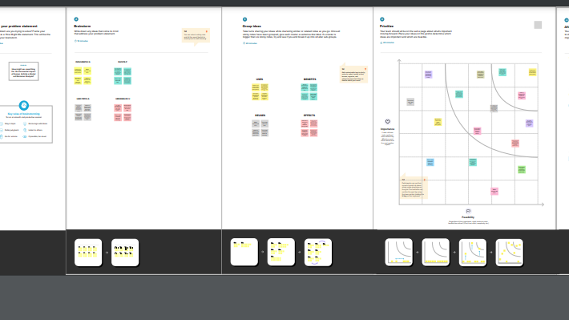

**3.RESULT**

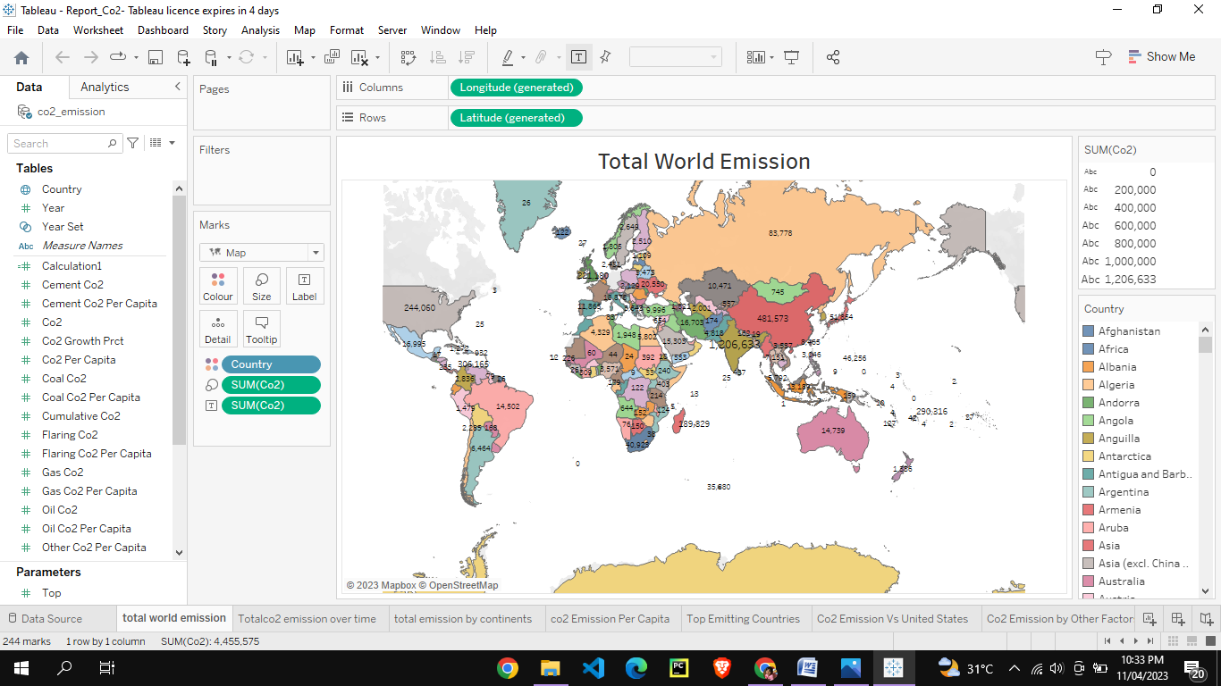

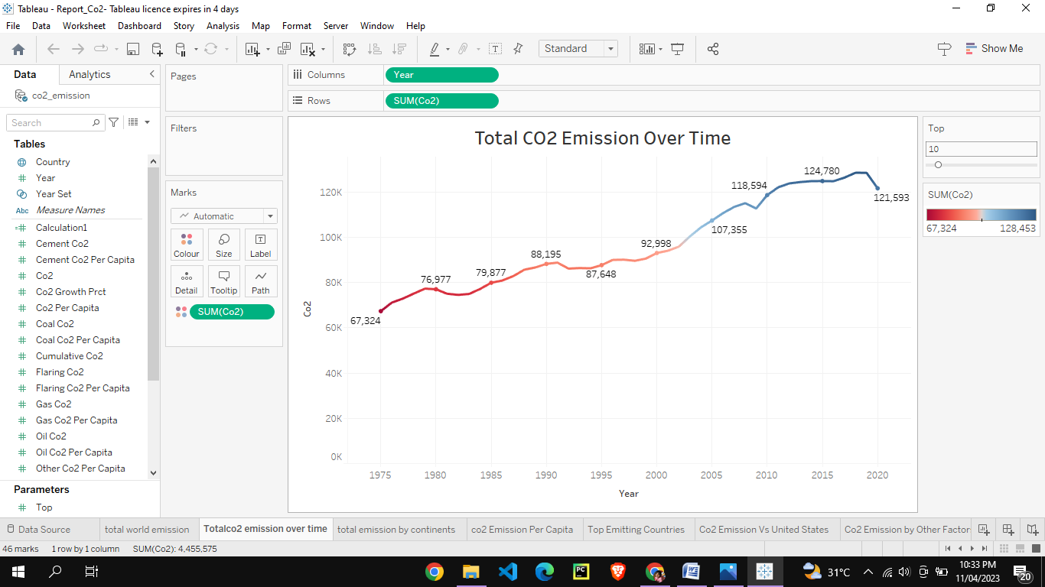

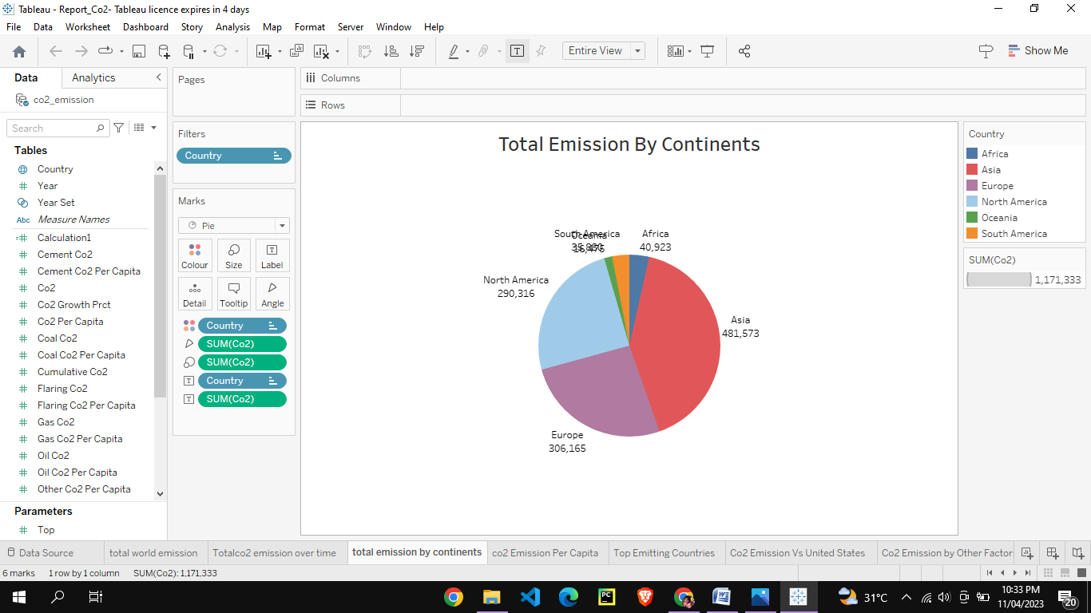

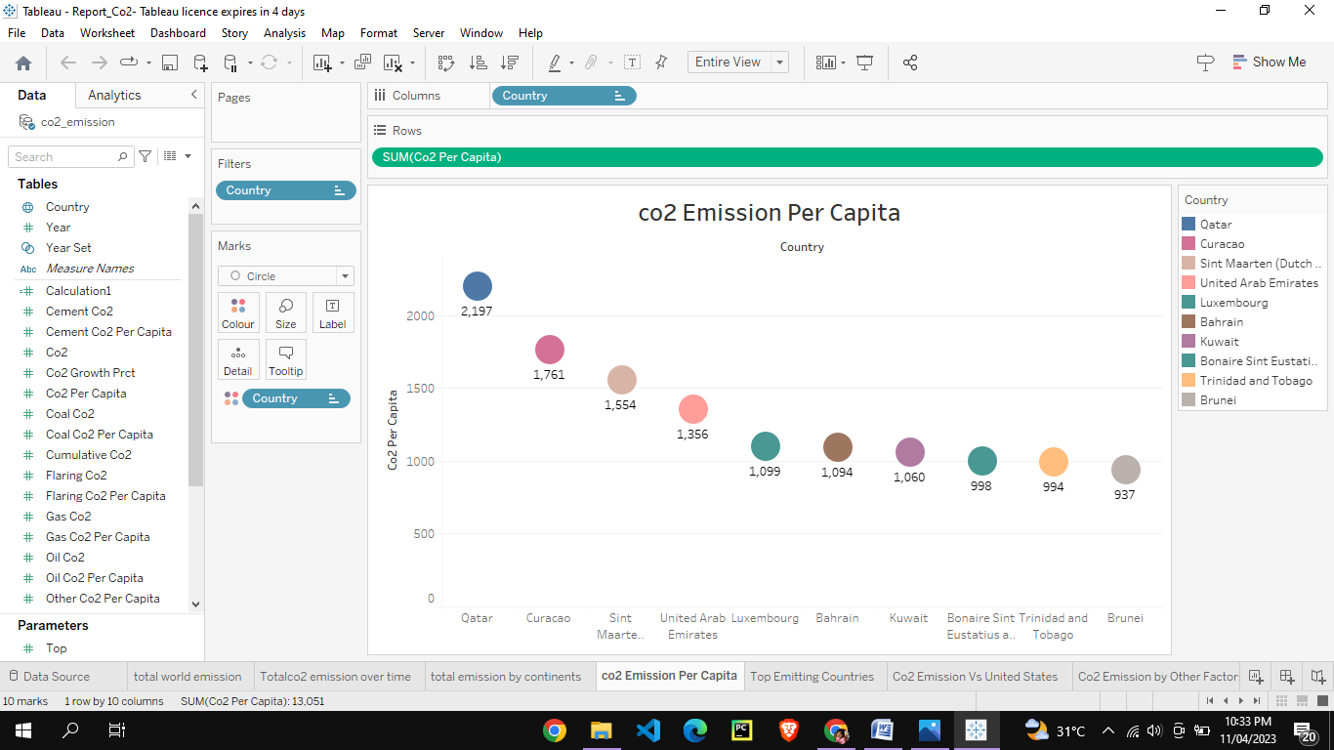

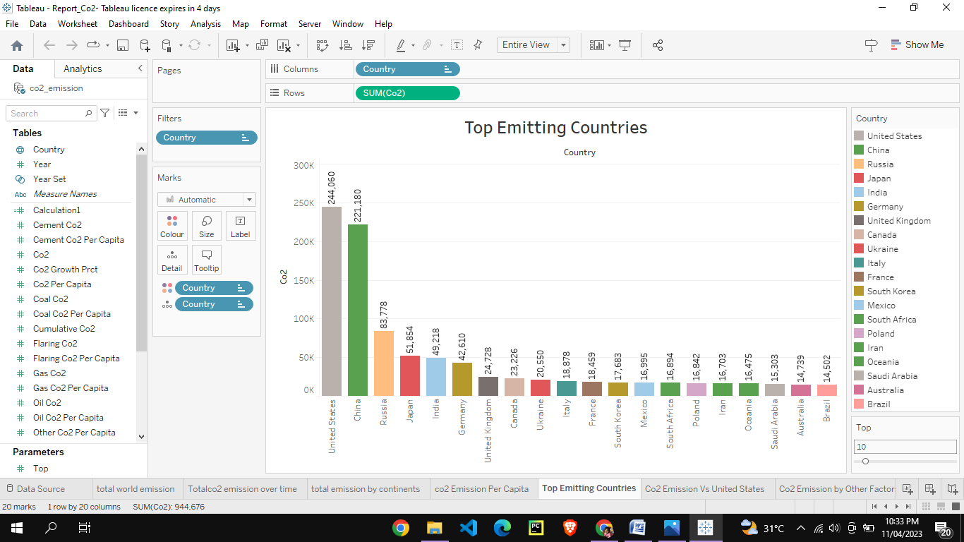

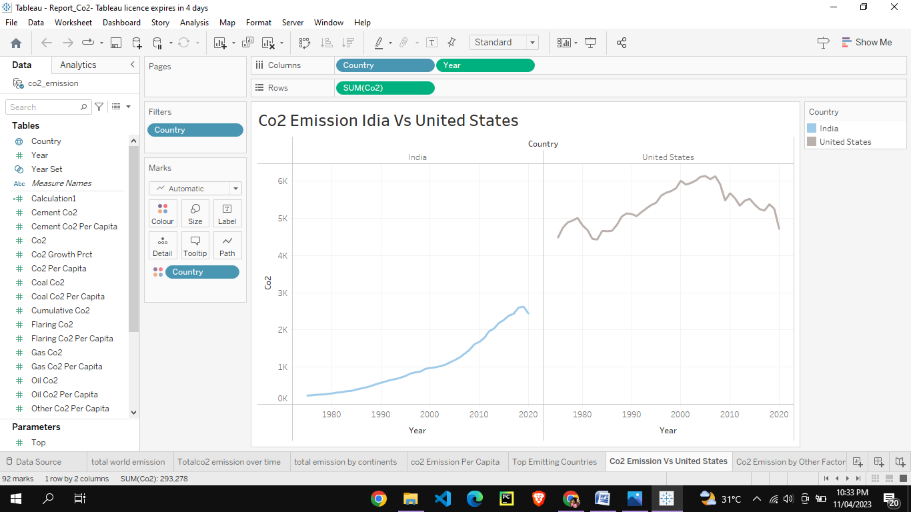

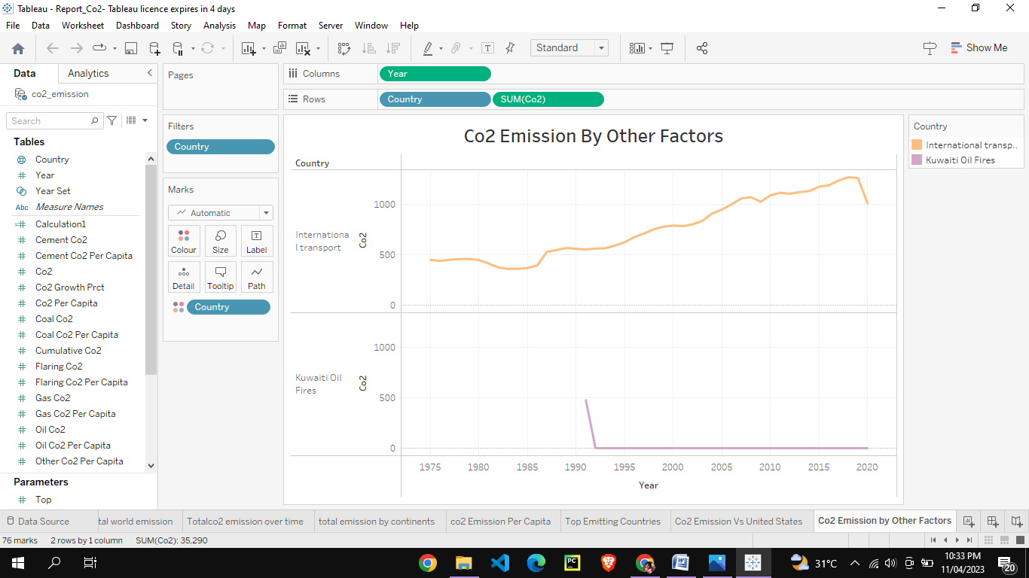

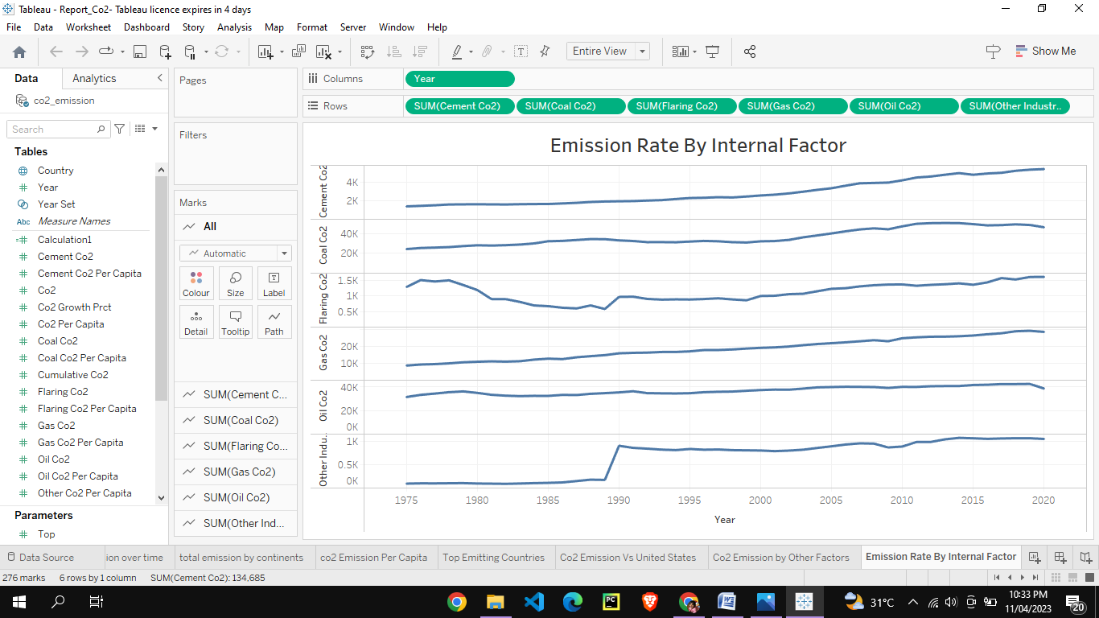

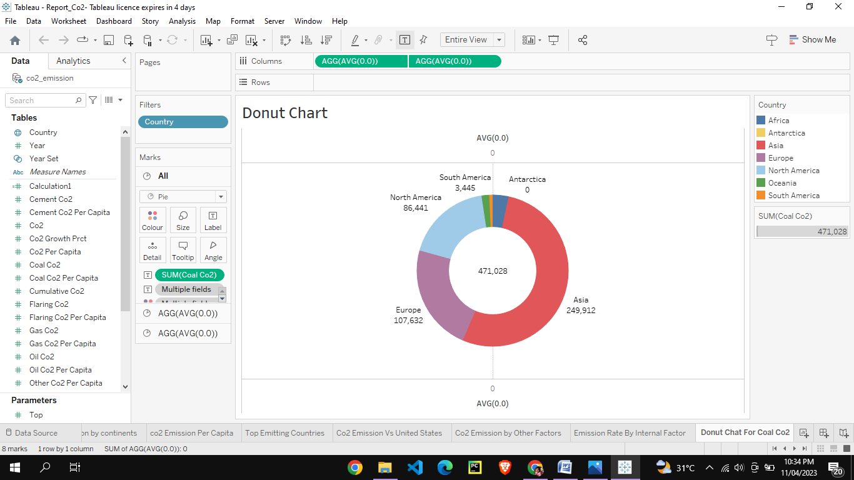

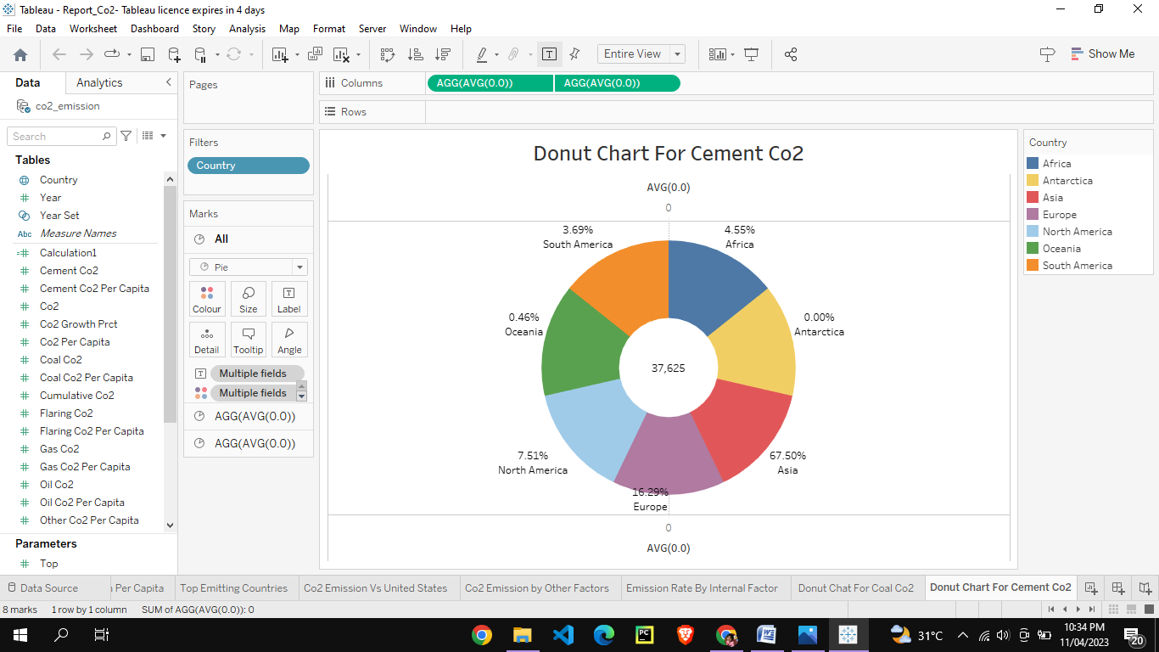

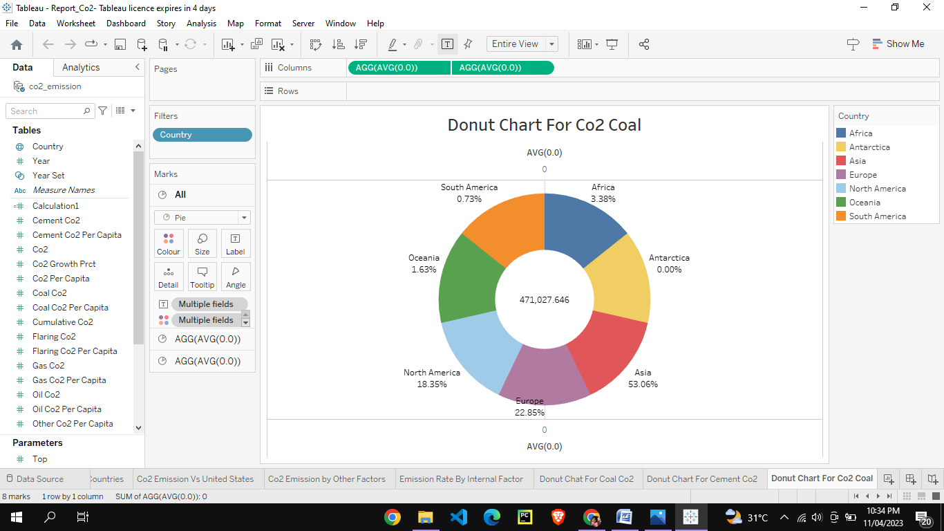

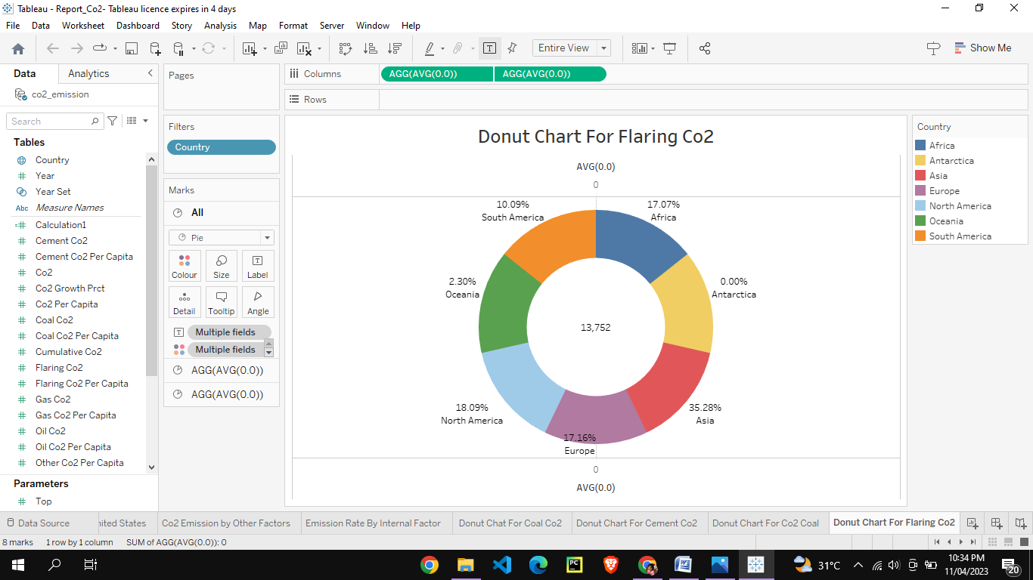

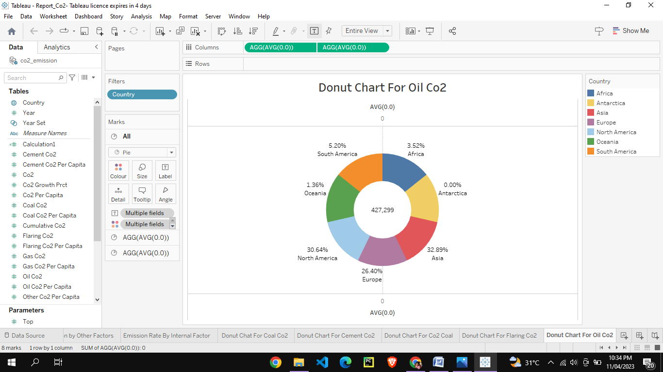

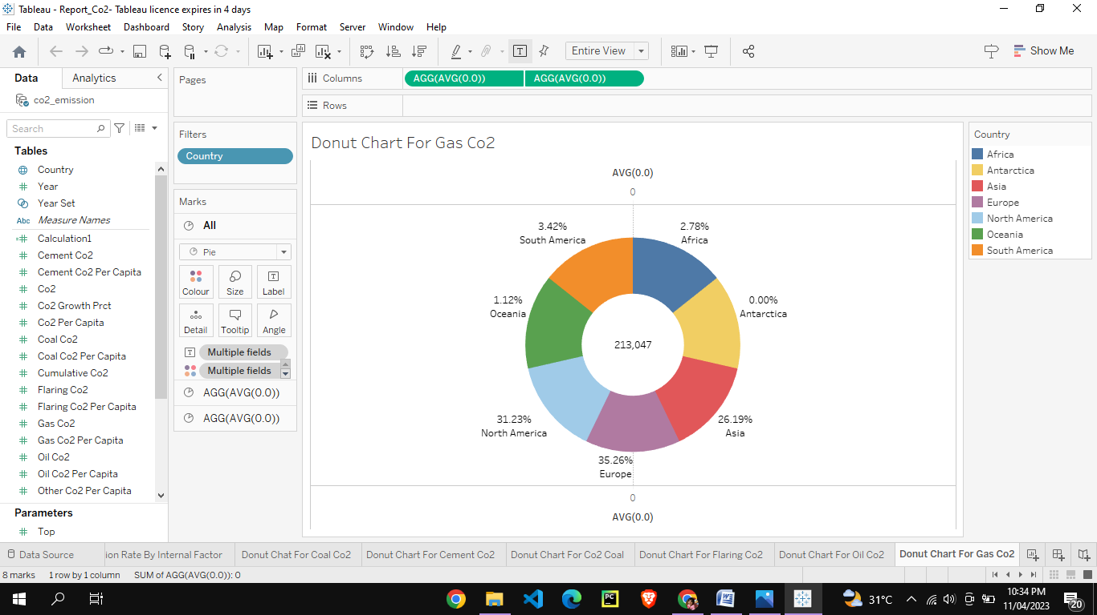

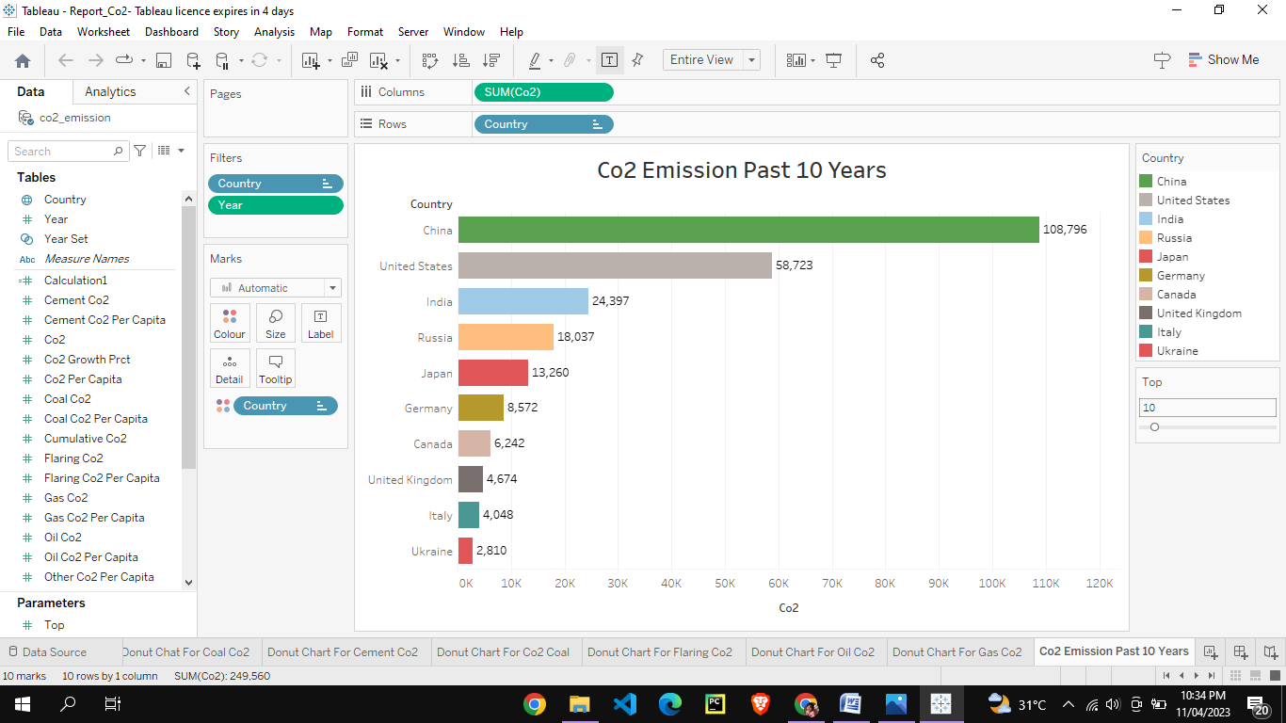

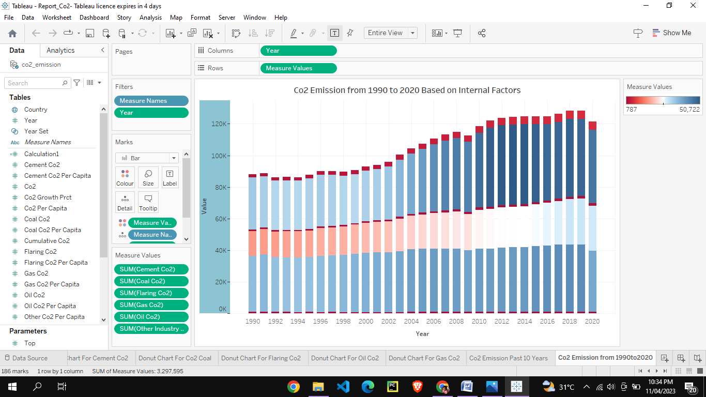

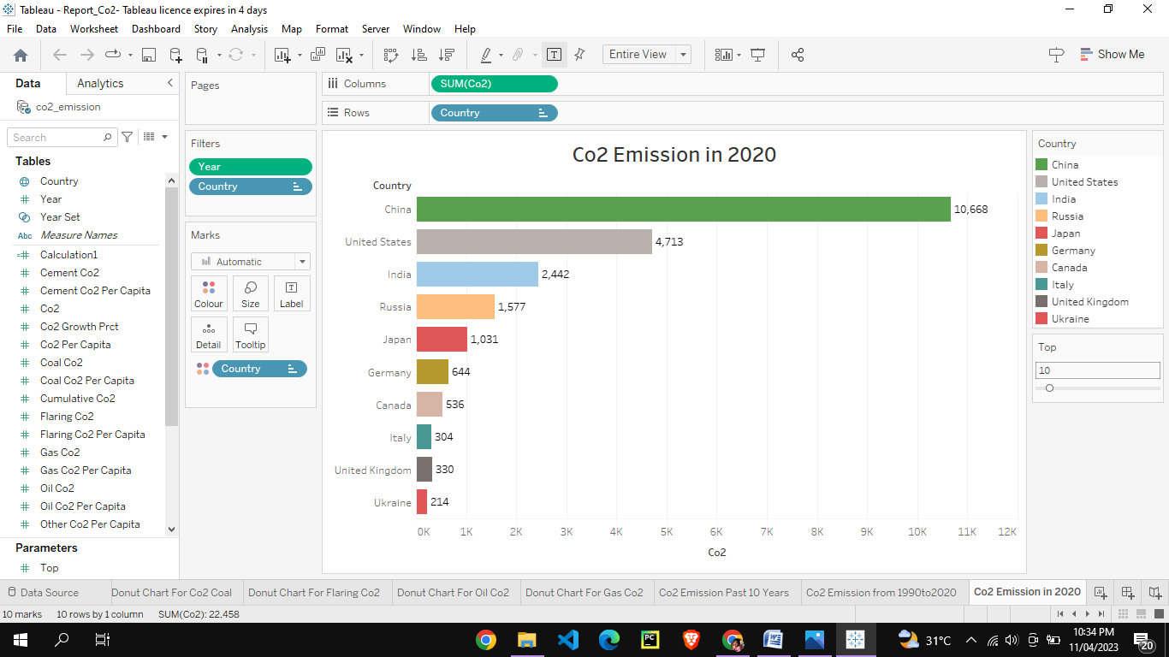

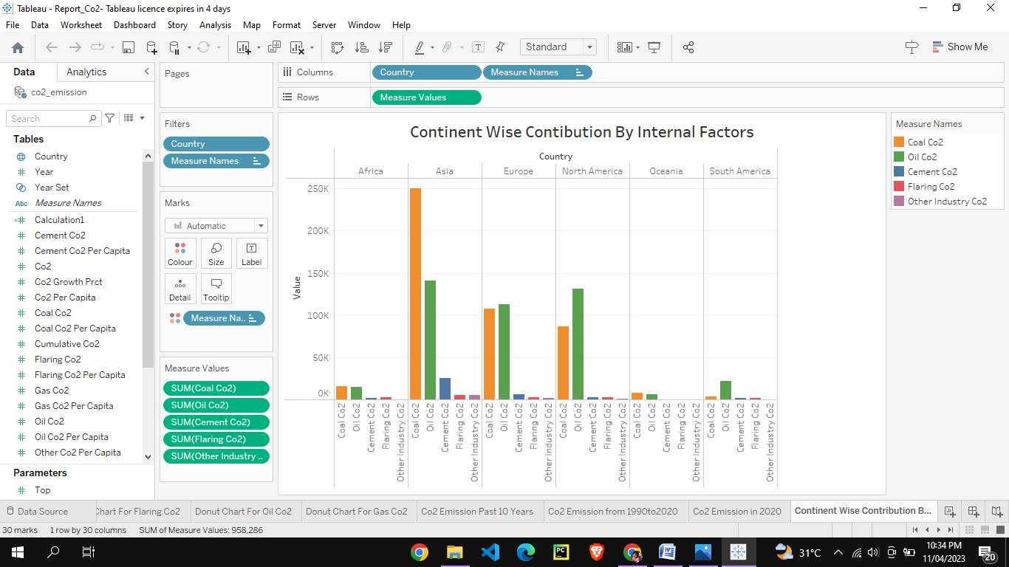

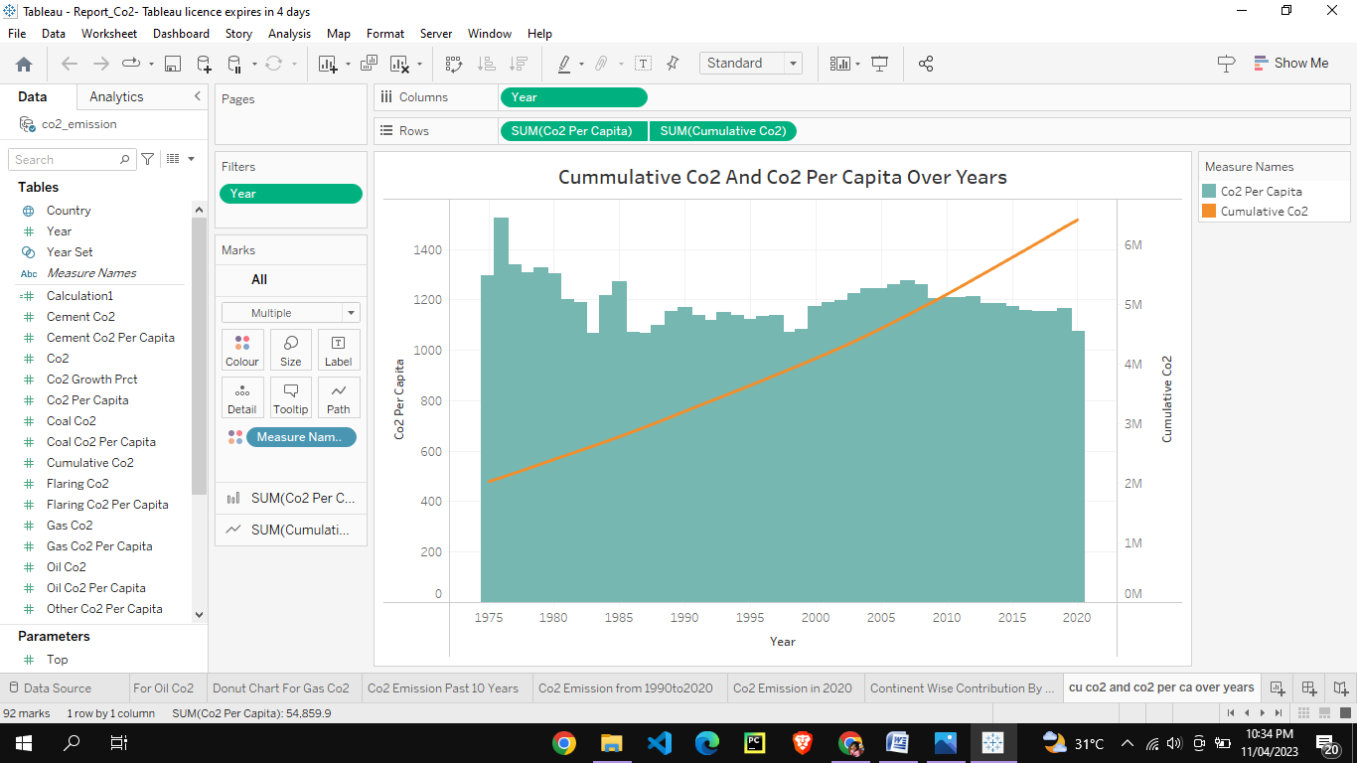

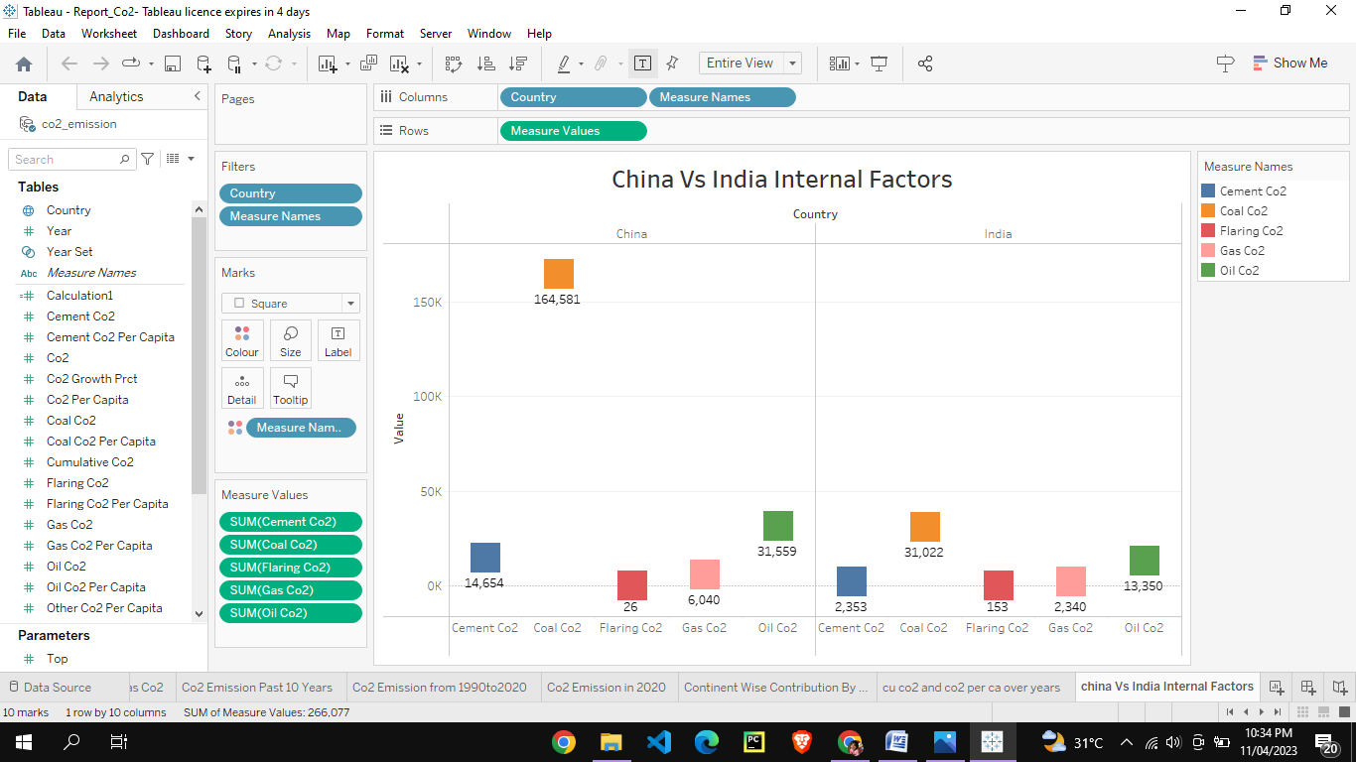

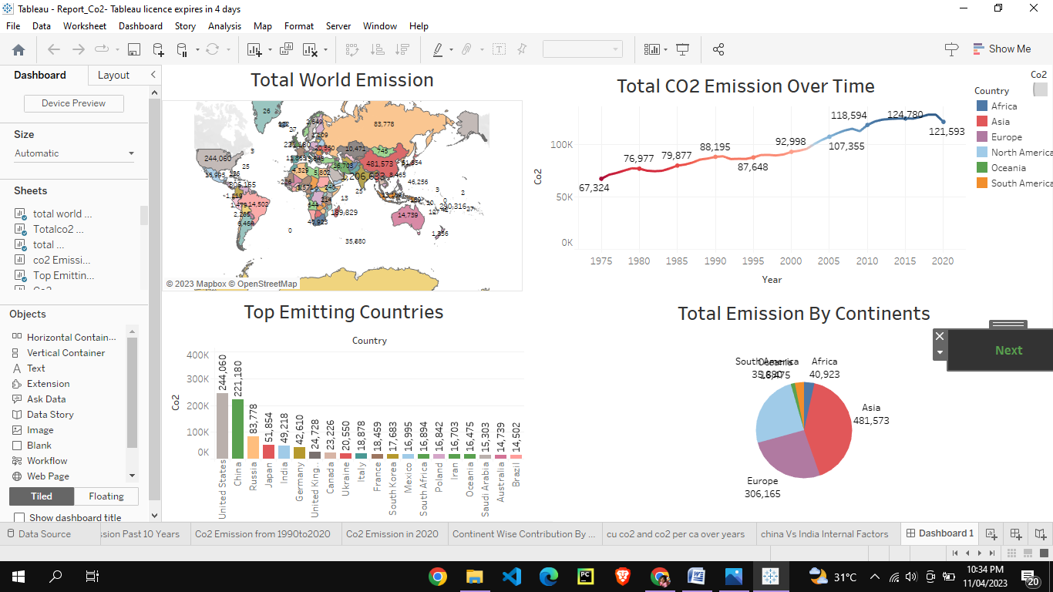

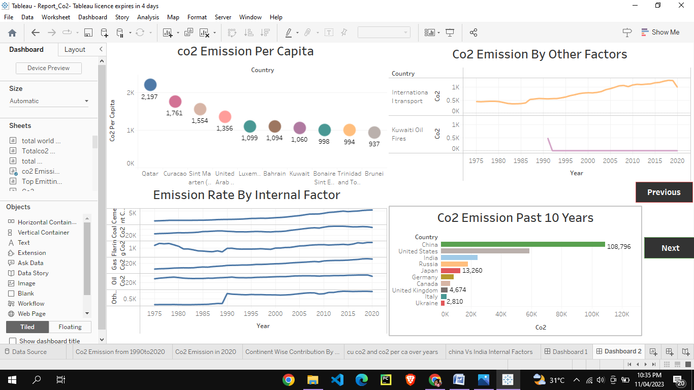

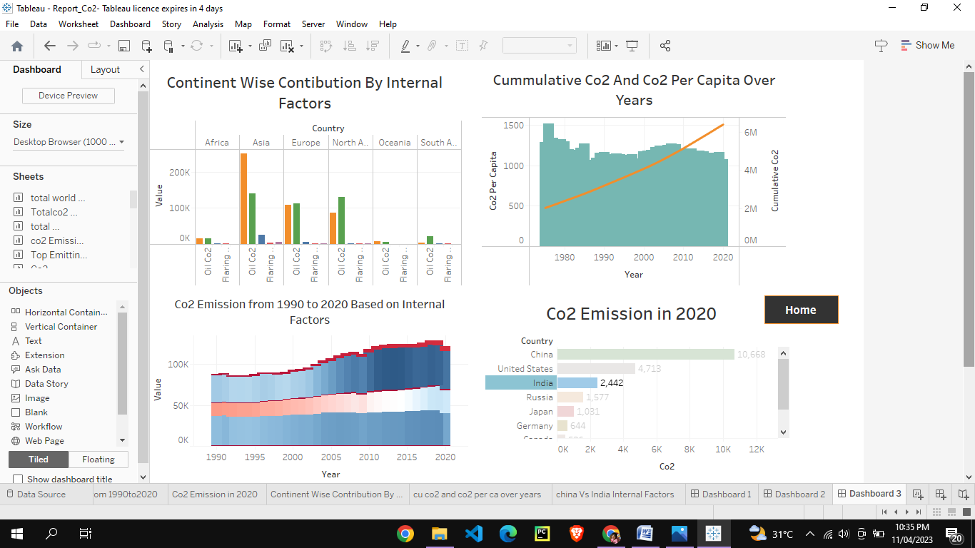

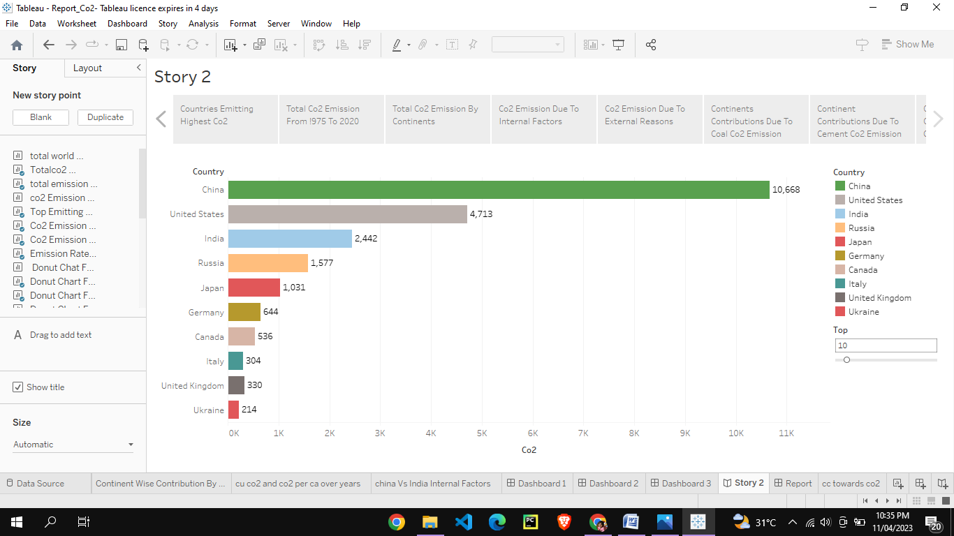

**4. ADVANTAGES & DISADVANTAGES**

**Advantages:**

**\* Green plant grows faster with more Co2. Many also becomes more drought-resistant because higher co2 levels allow plants to use water more efficiently are abundant vegetation from increased co2 is already.**

**\* Carbon dioxide is an important greenhouse gas that helps to trap heat in our atmosphere. Without it our plant would be inhospitality cold.**

**\* Increased Growth and plant size. Plantsmature faster resulting in faster harvests.**

**\* Faster maturity saves energy and fertilization costs per harvesting.**

**\* Increase in the number of size of flowers. Reduction in transpiration and increases water use efficiency.**

**Disadvantages:**

* **These may include headaches, dizziness, restlessness,a tingling or pins or needles feeling, difficulty breathing, surating,tideness increased heart rate,elevated blood pressure, coma, asphyxia and conclusions.**
* **An increase in Co2 concentration in our atmosphere is cauing average global temperatures to rise, disrupting other aspects of Earth’s climate.**
* **Co2 is one of the toxic gas.**
* **Co2 increase the Eath temperature and so global warming.**
* **Increase in percentage of co2 in air causes melting of snow and hence there are increasing sea water level.**

**APPLICATION:**

**Carbon dioxide in solid and in liquid form is used for refrigeration and cooling. It is used as an inert gas in chemical processes, in the storage of carbon powder and in fire extinguishers. Metals industry cardon dioxide is used in the manufacture of casting molds to enhance their hardness.**

**CONCLUSION:**

**The rising level of atmospheric natural resource that is progressively increasing food production and total biological output, in a world of otherwise diminishing natural resource of land, water, energy minerals and fertilizers. It is mean of inadvertently increasing the productivity of farming system and other photosynthetically active ecosystem.**

**FUTURE SCOPE:**

**If Global energy demand ontinues to grow rapidly and we meet it mostly with fossil fuels, Human Emissions of carbon dioxide could reach 75 Billion tons per year are more by the end of the century.**

**Atmospheric Carbon dioxide could be 800 ppm or higher condition are not seen on Earth for close to 50 million Years.**

**APPENDIX:**

**SQL Source code**

create schema glo_emission;

use glo_emission;

select * from cotwo_emission;

**HTML Source code**

<!DOCTYPE html>

<html lang="en">

<head>

  <meta charset="utf-8">

  <meta content="width=device-width, initial-scale=1.0" name="viewport">

  <title>Co2 Emission</title>

  <meta content="" name="description">

  <meta content="" name="keywords">

  <!-- Favicons -->

  <link href="assets/img/favicon.png" rel="icon">

  <link href="assets/img/apple-touch-icon.png" rel="apple-touch-icon">

  <!-- Google Fonts -->

  <link href="https://fonts.googleapis.com/css?family=Open+Sans:300,300i,400,400i,600,600i,700,700i|Jost:300,300i,400,400i,500,500i,600,600i,700,700i|Poppins:300,300i,400,400i,500,500i,600,600i,700,700i" rel="stylesheet">

  <!-- Vendor CSS Files -->

  <link href="assets/vendor/aos/aos.css" rel="stylesheet">

  <link href="assets/vendor/bootstrap/css/bootstrap.min.css" rel="stylesheet">

  <link href="assets/vendor/bootstrap-icons/bootstrap-icons.css" rel="stylesheet">

  <link href="assets/vendor/boxicons/css/boxicons.min.css" rel="stylesheet">

  <link href="assets/vendor/glightbox/css/glightbox.min.css" rel="stylesheet">

  <link href="assets/vendor/remixicon/remixicon.css" rel="stylesheet">

  <link href="assets/vendor/swiper/swiper-bundle.min.css" rel="stylesheet">

  <!-- Template Main CSS File -->

  <link href="assets/css/style.css" rel="stylesheet">

  <!-- =====================================================

  * Template Name: Arsha

  * Updated: Mar 10 2023 with Bootstrap v5.2.3

  * Template URL: https://bootstrapmade.com/arsha-free-bootstrap-html-template-corporate/

  * Author: BootstrapMade.com

  * License: https://bootstrapmade.com/license/

  ======================================================== -->

</head>

<body>

  <!-- ======= Header ======= -->

  <header id="header" class="fixed-top ">

    <div class="container d-flex align-items-center">

      <h1 class="C:\Template_co2\Arsha\assets\img\favicon.png"><a href="index.html">Co2</> </h1>

      <!-- Uncomment below if you prefer to use an image logo -->

      <!-- <a href="index.html" class="logo me-auto"><img src="assets/img/logo.png" alt="" class="img-fluid"></a>-->

      <nav id="navbar" class="navbar">

        <ul>

          <li><a class="nav-link scrollto active" href="#hero">Home</a></li>

          <li><a class="nav-link scrollto" href="#about">About</a></li>

          <li><a class="nav-link scrollto" href="#services">Dashboard</a></li>

          <li><a class="nav-link   scrollto" href="#portfolio">Story</a></li>

          <li><a class="nav-link scrollto" href="#team">Visualization</a></li>

          <li class="nav-link scrollto" href="#dropdwon">Report</a></li>

            <ul>

              <li><a href="#">Report</a></li>

               </li>

          <li><a class="nav-link scrollto" href="#contact">Contact</a></li>

          <li><a class="getstarted scrollto" href="#about">Get Started</a></li>

        </ul>

        <i class="bi bi-list mobile-nav-toggle"></i>

      </nav><!-- .navbar -->

    </div>

  </header><!-- End Header -->

  <!-- ======= Hero Section ======= -->

  <section id="hero" class="d-flex align-items-center">

    <div class="container">

      <div class="row">

        <div class="col-lg-6 d-flex flex-column justify-content-center pt-4 pt-lg-0 order-2 order-lg-1" data-aos="fade-up" data-aos-delay="200">

          <h1>Welcome to Global Co2 Emission Analysis For year 2020</h1>

          <h2>Carbon dioxide emission  are the Primary driver of global climate change. It's widely recognised that to avoid the worst impacts of climate change,the world needs to urgently reduce emissions.</h2>

          <div class="d-flex justify-content-center justify-content-lg-start">

            <a href="#about" class="btn-get-started scrollto">Get Started</a>

           </div>

        </div>

        <div class="col-lg-6 order-1 order-lg-2 hero-img" data-aos="zoom-in" data-aos-delay="200">

          <img src="assets/img/hero-img.png" class="img-fluid animated" alt="">

        </div>

      </div>

    </div>

  </section><!-- End Hero -->

  <main id="main">

   <!-- ======= About Us Section ======= -->

    <section id="about" class="about">

      <div class="container" data-aos="fade-up">

        <div class="section-title">

          <h2>About Us</h2>

        </div>

    </div>

    </section><!-- End About Us Section -->

    <!-- ======= Why Us Section ======= -->

    <section id="why-us" class="why-us section-bg">

      <div class="container-fluid" data-aos="fade-up">

        <div class="row">

          <div class="col-lg-7 d-flex flex-column justify-content-center align-items-stretch  order-2 order-lg-1">

      </div>

          <div class="col-lg-5 align-items-stretch order-1 order-lg-2 img" style='background-image: url("assets/img/why-us.png");' data-aos="zoom-in" data-aos-delay="150">&nbsp;</div>

        </div>

      </div>

    </section><!-- End Why Us Section -->

    <!-- ======= Skills Section ======= -->

    <section id="skills" class="skills">

      <div class="container" data-aos="fade-up">

        <div class="row">

          </div>

    </section><!-- End Skills Section -->

    <!-- ======= Services Section ======= -->

    <section id="services" class="services section-bg">

      <div class="container" data-aos="fade-up">

        <div class="section-title">

          <h2>Dashboard</h2>

          <div class='tableauPlaceholder' id='viz1681102099634' style='position: relative'><noscript><a href='#'><img alt='Dashboard 1 ' src='https:&#47;&#47;public.tableau.com&#47;static&#47;images&#47;Co&#47;Co2_Dash_demo&#47;Dashboard1&#47;1_rss.png' style='border: none' /></a></noscript><object class='tableauViz'  style='display:none;'><param name='host_url' value='https%3A%2F%2Fpublic.tableau.com%2F' /> <param name='embed_code_version' value='3' /> <param name='site_root' value='' /><param name='name' value='Co2_Dash_demo&#47;Dashboard1' /><param name='tabs' value='no' /><param name='toolbar' value='yes' /><param name='static_image' value='https:&#47;&#47;public.tableau.com&#47;static&#47;images&#47;Co&#47;Co2_Dash_demo&#47;Dashboard1&#47;1.png' /> <param name='animate_transition' value='yes' /><param name='display_static_image' value='yes' /><param name='display_spinner' value='yes' /><param name='display_overlay' value='yes' /><param name='display_count' value='yes' /><param name='language' value='en-US' /><param name='filter' value='publish=yes' /></object></div>                <script type='text/javascript'>                    var divElement = document.getElementById('viz1681102099634');                    var vizElement = divElement.getElementsByTagName('object')[0];                    vizElement.style.width='100%';vizElement.style.height=(divElement.offsetWidth*0.75)+'px';                    var scriptElement = document.createElement('script');                    scriptElement.src = 'https://public.tableau.com/javascripts/api/viz_v1.js';                    vizElement.parentNode.insertBefore(scriptElement, vizElement);                </script>

          </div>

        <div class="row">

          </div>

      </div>

    </section><!-- End Services Section -->

    <!-- ======= Cta Section ======= -->

    <section id="cta" class="cta">

      <div class="container" data-aos="zoom-in">

    </div>

    </section><!-- End Cta Section -->

    <!-- ======= Portfolio Section ======= -->

    <section id="portfolio" class="portfolio">

      <div class="container" data-aos="fade-up">

        <div class="section-title">

          <h2>Story</h2>

          <div class='tableauPlaceholder' id='viz1681102481675' style='position: relative'><noscript><a href='#'><img alt='Co2 Emission Story ' src='https:&#47;&#47;public.tableau.com&#47;static&#47;images&#47;Co&#47;Co2_Story&#47;Co2EmissionStory&#47;1_rss.png' style='border: none' /></a></noscript><object class='tableauViz'  style='display:none;'><param name='host_url' value='https%3A%2F%2Fpublic.tableau.com%2F' /> <param name='embed_code_version' value='3' /> <param name='site_root' value='' /><param name='name' value='Co2_Story&#47;Co2EmissionStory' /><param name='tabs' value='no' /><param name='toolbar' value='yes' /><param name='static_image' value='https:&#47;&#47;public.tableau.com&#47;static&#47;images&#47;Co&#47;Co2_Story&#47;Co2EmissionStory&#47;1.png' /> <param name='animate_transition' value='yes' /><param name='display_static_image' value='yes' /><param name='display_spinner' value='yes' /><param name='display_overlay' value='yes' /><param name='display_count' value='yes' /><param name='language' value='en-US' /><param name='filter' value='publish=yes' /></object></div>                <script type='text/javascript'>                    var divElement = document.getElementById('viz1681102481675');                    var vizElement = divElement.getElementsByTagName('object')[0];                    vizElement.style.width='100%';vizElement.style.height=(divElement.offsetWidth*0.75)+'px';                    var scriptElement = document.createElement('script');                    scriptElement.src = 'https://public.tableau.com/javascripts/api/viz_v1.js';                    vizElement.parentNode.insertBefore(scriptElement, vizElement);                </script>

          </div>

        </div>

    </section><!-- End Portfolio Section -->

    <!-- ======= Team Section ======= -->

    <section id="team" class="team section-bg">

      <div class="container" data-aos="fade-up">

        <div class='tableauPlaceholder' id='viz1681118366187' style='position: relative'><noscript><a href='#'><img alt='   VISUALIZATIONS ' src='https:&#47;&#47;public.tableau.com&#47;static&#47;images&#47;Vi&#47;Visualization_16811183148400&#47;Visualization&#47;1_rss.png' style='border: none' /></a></noscript><object class='tableauViz'  style='display:none;'><param name='host_url' value='https%3A%2F%2Fpublic.tableau.com%2F' /> <param name='embed_code_version' value='3' /> <param name='site_root' value='' /><param name='name' value='Visualization_16811183148400&#47;Visualization' /><param name='tabs' value='no' /><param name='toolbar' value='yes' /><param name='static_image' value='https:&#47;&#47;public.tableau.com&#47;static&#47;images&#47;Vi&#47;Visualization_16811183148400&#47;Visualization&#47;1.png' /> <param name='animate_transition' value='yes' /><param name='display_static_image' value='yes' /><param name='display_spinner' value='yes' /><param name='display_overlay' value='yes' /><param name='display_count' value='yes' /><param name='language' value='en-US' /><param name='filter' value='publish=yes' /></object></div>                <script type='text/javascript'>                    var divElement = document.getElementById('viz1681118366187');                    var vizElement = divElement.getElementsByTagName('object')[0];                    vizElement.style.width='1000px';vizElement.style.height='827px';                    var scriptElement = document.createElement('script');                    scriptElement.src = 'https://public.tableau.com/javascripts/api/viz_v1.js';                    vizElement.parentNode.insertBefore(scriptElement, vizElement);                </script>

       </div>

 </div>

 </section><!-- End Team Section -->

    <div class="section-title"></div>

    </div>

    <!-- ======= Pricing Section ======= -->

    <<section id="portfolio" class="portfolio">

      <div class="container" data-aos="fade-up">

        <div class="section-title">

          <h2>Report</h2>

          <div class='tableauPlaceholder' id='viz1681191517706' style='position: relative'><noscript><a href='#'><img alt='Top Co2 Emitting Countries For Past 10 Years     China is the highest Co2  Emitting among the other countries. United States is the second highest co2 Emitting country.  India  is the Third highest Co2 Emitting Country. ' src='https:&#47;&#47;public.tableau.com&#47;static&#47;images&#47;Re&#47;Report_16811914666870&#47;Report&#47;1_rss.png' style='border: none' /></a></noscript><object class='tableauViz'  style='display:none;'><param name='host_url' value='https%3A%2F%2Fpublic.tableau.com%2F' /> <param name='embed_code_version' value='3' /> <param name='site_root' value='' /><param name='name' value='Report_16811914666870&#47;Report' /><param name='tabs' value='no' /><param name='toolbar' value='yes' /><param name='static_image' value='https:&#47;&#47;public.tableau.com&#47;static&#47;images&#47;Re&#47;Report_16811914666870&#47;Report&#47;1.png' /> <param name='animate_transition' value='yes' /><param name='display_static_image' value='yes' /><param name='display_spinner' value='yes' /><param name='display_overlay' value='yes' /><param name='display_count' value='yes' /><param name='language' value='en-US' /><param name='filter' value='publish=yes' /></object></div>                <script type='text/javascript'>                    var divElement = document.getElementById('viz1681191517706');                    var vizElement = divElement.getElementsByTagName('object')[0];                    if ( divElement.offsetWidth > 800 ) { vizElement.style.width='1000px';vizElement.style.height='827px';} else if ( divElement.offsetWidth > 500 ) { vizElement.style.width='1000px';vizElement.style.height='827px';} else { vizElement.style.width='100%';vizElement.style.height='927px';}                     var scriptElement = document.createElement('script');                    scriptElement.src = 'https://public.tableau.com/javascripts/api/viz_v1.js';                    vizElement.parentNode.insertBefore(scriptElement, vizElement);                </script>

            </div>

          </div>

            </div>

          </div>

            </div>

          </div>

        </div>

      </div>

    </section><!-- End Pricing Section --

    </div>

 </main>

 <!-- End #main --

 <div id="preloader"></div>

  <a href="#" class="back-to-top d-flex align-items-center justify-content-center"><i class="bi bi-arrow-up-short"></i></a>

  <!-- Vendor JS Files -->

  <script src="assets/vendor/aos/aos.js"></script>

  <script src="assets/vendor/bootstrap/js/bootstrap.bundle.min.js"></script>

  <script src="assets/vendor/glightbox/js/glightbox.min.js"></script>

  <script src="assets/vendor/isotope-layout/isotope.pkgd.min.js"></script>

  <script src="assets/vendor/swiper/swiper-bundle.min.js"></script>

  <script src="assets/vendor/waypoints/noframework.waypoints.js"></script>

  <script src="assets/vendor/php-email-form/validate.js"></script>

  <!-- Template Main JS File -->

  <script src="assets/js/main.js"></script>

</body>

</html>